The core design elements for Quest: To Be Defined

Quest: To Be Defined Design Document

By James Moran

Contents

Elevator Pitch 2

Story 2

Characters 6

The Player 6

PIBot 6

CombatAdmin 6

Sacramento 6

Pvt. Matterson 6

Edit 1 6

Level/Environment Design 7

Edit 1 8

Gameplay 9

Player Movement System 9

NPC AI Behaviour 9

Weapons in QTBDIntro 9

Weapon Pick up Confirmation 9

Weapon Statistics System 9

Sacramento’s Introduction 10

The Tutorial Enemy and the Combat Tutorial/Dialog Tutorial 10

Sacramento’s Movement Animations 10

Second Section of the Introduction Level 11

Private Matterson 11

Art 11

Sound and Music 11

User Interface and Game Controls 12

Main menu 12

New Game 12

Weapon Ammo HUD Element 12

Armour HUD Element 13

Carrying Mass HUD Element 13

Test Report 13

Post-mortem 13

Appendix A: NPC AI Behaviour 14

How PIBot behaves in the first level 14

The CombatAdmin 14

Sacramento’s AI 14

Appendix B: Class Inheritance Structure 15

Appendix C: Weapons 16

The Brick Weapon 16

Appendix D: Art Style Guide 17

Sketches 17

Player Character 17

PIBot (Based on Fig. 2, from Appendix E: Figures) 17

Asset Prototype Screenshots 18

Main Menu 18

Default Player HUD 18

3DSMax Prototype Render Views 19

Pvt. Matterson 3DSMax Render View 19

Top-Down Level Overview 19

QTBDIntro 19

QTBDIntroTesting 20

Appendix E: Sound and Music 21

Appendix F: Figures 22

Figure 1: Weapon/Item Pickup Confirmation 22

Figure 2: Galactic Ranger from Ratchet and Clank: Up Your Arsenal 22

# Elevator Pitch

A Third-Person shooter, in which the player has statistics related to their health and armour, can obtain items such as weapons and armour, follows linear routes through a level to complete an objective and they will also meet certain characters along their route that can help or hinder them. These features are tied together by a story, which grants context to the actions the Player is taking, as well as the respective consequences of these actions.

# Story

At the mid-point (absolute), of the twenty-second century, you are walking along a canyon path. The canyon is layered in evenly cut grass (interesting…), with the sides too steep to scale, so indeed; you keep walking along, until you come across a decline in the canyon path, where you notice a metal mass that seems to equate to a deactivated robot, but without even a moment to observe this construct; it comes to life, with a pleasant and enthusiastic greeting:

(Note: That although there are multiple dialog options for the Player to choose in game, which will affect the story. To provide the story for this section; I have chosen one specific route.)

“Greetings unknown person! I Think I must have been falling asleep here, waiting for someone like you to walk down the road and notice me!”

“I am PIBot, that is; ‘Personal Intelligence’ robot.”

“I say falling asleep, but I don’t mean really, I am a robot after all…but I can imitate sleep, must have done so while I was being bored, waiting.”

“Guess I must have been left here after the war of Twenty-One, ah well.”

“As such, I have something of the upmost importance to say, but first; what is your name? Do tell me…”

You tell PIBot that your name is…”Unknown”.

“’Unknown’ eh? …Very well, I shall hence forth, refer to you as unknown then, hmm…the unknown person, not too interesting…”

“Ok then, I’ll follow you! Let us go down the road a bit, as I have something to tell you, don’t want anyone sneaking up on us you see so down the road a bit, then I’ll tell you.”

So our group as it were; you and PIBot, walk along the path a fair distance, to ensure that they could procure the necessary degree of privacy.

When PIBot believed that they had put suitable distance between them, from where PIBot had awakened to your presence, they were ready to tell you what they knew…“Right, the thing I need to tell you is tha-” …all of a sudden though, looking upwards; both them and you could see an interesting flying contraption…“Greetings team that requires my help and assistance! I am the CombatAdmin. I administrate combat, as well as a few other tasks, in addition to combat administrating.”

“Good to know, other robot that appeared out of nowhere.”

“Regardless, I must tell you what I know, or we could be in trouble, what I need to tell you, is tha-”

…although PIBot has tried to tell the Player what they know once again (after the CombatAdmin interrupted this information outlet by PIBot), they get interrupted again…“Ah, there you are, I am the one, the only, Sacramento! Ha-ha! Tell me, where are you off to then?”

Even though you are surprised that this person appeared out of nowhere, you respond fairly quickly with: “Nowhere in particular.”

Sacramento then asks you: “Good…then you won’t mind staying here now, will you?”

An interesting question, as given its negative implication, you respond with “Yes”; as you would not mind staying put. As this is the case; Sacramento tells you-: “Ah...I have a plan to inform you of then, you see, I have scouted out what is up ahead, I have seen a bunch of military grunts out there, I will assist you with them, by using this ground to ground missile I have here: *Shows the missile to the player* I just require a target location of your choosing, I also have a shotgun on me, to blast them with, let’s get started then.”

So now; Sacramento has joined your group as well, after warning you and PIBot of what you can expect up ahead.

Banking left along the canyon path, you and your group see a sub-segment of the canyon path to the left of the main canyon path (after already turning left once), which then prompts Sacramento to recall a certain snippet of info…“Wait up there, just here *Points at the canyon sub-segment* is where I left a certain item. I think we should collect that.”

So our team heads into this part of the canyon, off to the left of the main canyon path. Only a few seconds after heading into this segment of the canyon, Sacramento catches sight of the aforementioned item…“Ah, there it is, my beloved speciality grenade, hmm…although I was going to look for this item earlier, I believe it would make sense if you took it.” “Very well then.” You say to Sacramento, taking his speciality grenade from him, as he hands it to you.

Getting back onto the main canyon path, 75 metres further down the path, our team notices that the canyon path is getting narrower and not only that; there is a minor incline in the canyon, noticeable, but not too hard for our team to scale up. Upon the group members’ (including yourself) minor alteration to their current altitude, you notice 2 seemingly useful items; a machine-pistol and some body armour. “I think those are decent items to make use of…hold on, what is your name?” says Sacramento to you and so, you feel as though it would make sense to equip these items. Whilst getting yourself ready with this equipment; you mention to Sacramento that “My name is Unknown, by all means, I also think it would make sense to use these items”.

Our team carries on along this narrower, raised, branch of the canyon path for about 9 metres longer, before seeing this branch expand outwards, into a much wider clearing for this canyon. Moving further ahead, you and the rest of the team take cover behind a slope, not too far into where the canyon opens up.

Glancing for a brief moment over the top of the slope, you see 6 people wearing soldier uniforms, grouped together and currently idle, 1 of them keeping a lookout along the entrance to this wider canyon segment. Even looking over the top, they still seem to have not noticed you or any other members of the team (including the CombatAdmin for an unknown reason), hiding back behind the slope again, out of sight of these soldiers, you ask Sacramento “So who are they?” “Ah, those are the bunch of military grunts I told you about earlier. Oh, in order for my plan to work, I have connected to that CombatAdmin’s video feed, to lock onto their location, to fire a missile from the launcher I showed you earlier, without them seeing us.” “I thought CombatAdmin had become unusually quiet…” remarked PIBot. “Ah don’t worry, this CombatAdmin of yours is fine, I just wanted to get line of sight to those grunts, in an incognito way”. “So long as the CombatAdmin is ok…”.

With the CombatAdmin’s assistance, Sacramento follows through with their plan: “Fire in ze hole…” he whispers quietly. And indeed, a missile is released from his launcher. With the missile heading straight up, at approximately 500 metres; the missile plunges towards the target location and at this point in the missile’s trajectory (before impact), the grunts are alerted to the presence of an enemy, drawing their weapons and charging towards your group, hiding behind the slope.

Peaking over the top once again, you notice that this is case. As bullets fly over the top of your head, you decide that it is sensible to take cover once again. You urgently ask Sacramento “So what now in this plan of yours!?”, with Sacramento simply (and calmly), stating that “Well, I will guide ze missile towards them, distract them please.”.

So you quickly crawl over to the left of where the rest of the group is hiding, with your machine pistol at the ready, with the intent to peek out and fire a few shots in their general direction (to distract them from the impending missile impact). Looking over the top once again, you take aim and fire 1 shot (pulling the trigger back for a millisecond and then releasing, to not discharge more than one round), but unfortunately, this simply glances off the soldier grunt’s helmet (that you were aiming at). As fast as lighting, they are alerted to your presence at this point in the slope now, not only altering their path of fire, but also their velocity, so that this particular soldier is now moving towards your location.

Ducking behind the slope for but a moment to think again about how to use your weapon, you peek out once more, but this time; pining the trigger, which causes the weapon to discharge multiple shots, without a moment’s notice between each shot. Luckily; this causes the soldier charging directly at you, to fall, crying out from the rounds impacting them (so they are still alive), but no longer charging at you.

This time, the other soldiers are alerted to your presence as well, altering their direction, so that they are charging towards you and so; more bullets whizz past and over you.

“How long now?!!” you shout towards Sacramento. “Sooner than you might think…”. This is absolutely the case; as not even a second later, the missile impacts the ground near these soldier grunts, dismembering them as though their armour matters not.

You and the rest of the group cease hiding behind the slope, rising to stand and see how successful Sacramento’s plan turned out.

Indeed, all bar one of the soldiers have vanished, with the one grunt, lying face up on the ground, with no signs of life in them.

“Of course my plan worked, z’ehy had not even known what hit z’ehm.” Stated Sacramento, feeling accomplished. “Well that is most useful to know Sacramento, I had no worries at all.” Said PIBot in response, quite delightfully. “So now what?” you ask the group. “Well, I believe that plan resulted in success.” Was the response given by the CombatAdmin. “And I can detect no more enemies nearby.”. “Let’s carry on, zehn…” “Yes, continue onwards we shall and will.” Mentioned PIBot (after Sacramento’s piece).

So you and the group continue onwards and upwards, in what would soon become an adventure, most worthy of note.

# Characters

## The Player

The Player Character, is indeed, a character in the game and also the pawn that the Player will control, with a distressing past that they wish to get away from, they are wandering about the world and have come across this canyon path, which they follow to begin the story.

## PIBot

PIBot (the ‘Personal Intelligence Robot’), is met by the Player, when they start traversing along the canyon path, for the first level (PIBot is lying on the ground). With important information to tell the Player, they will follow the Player, as they move along the canyon trail, attempting to inform the Player of what they know, at various points on this trail.

## CombatAdmin

The CombatAdmin (a flying robot), appears at one of these points on the canyon trail, following the Player and PIBot along, as they follow this trail, with the intent to administrate any combat that occurs…and not much else.

## Sacramento

Soon after the CombatAdmin appears, PIBot attempts to inform the Player of their important knowledge, but is once again interrupted, this time though, by Sacramento. He is presumably a human, with French origins (given his accent). It appears that they intended to come upon the Player Character, teleporting in to their location for when the Player will first encounter them. He has an interesting character to him and he can become the Player’s ally, or enemy…

## Pvt. Matterson

There are 6 of them in the first level, which the Player will encounter towards the end. These are the ‘military grunts’ that Sacramento will mention, if the Player wants to hear Sacramento’s plan. Even if the Player would not want to hear Sacramento’s plan earlier, they will still have to deal with these soldiers. They are clones (all instances of the original Pvt. Matterson), with simply a number appended to the end of ‘Pvt. Matterson’, to uniquely identify each soldier (Pvt. Matterson1, Pvt. Matterson2 etc.).

## Edit 1

The first few sections of the story are detailed to the Player, in an exposition HUD Widget, shown before loading the first level (as opposed to the initial segment of the story, getting played out, by the Player). This is for testing purposes; to allow the Play Tester to get to the gameplay faster. This Widget has an appearance as per such:

# Level/Environment Design

The layout of the first level is currently what is shown below:

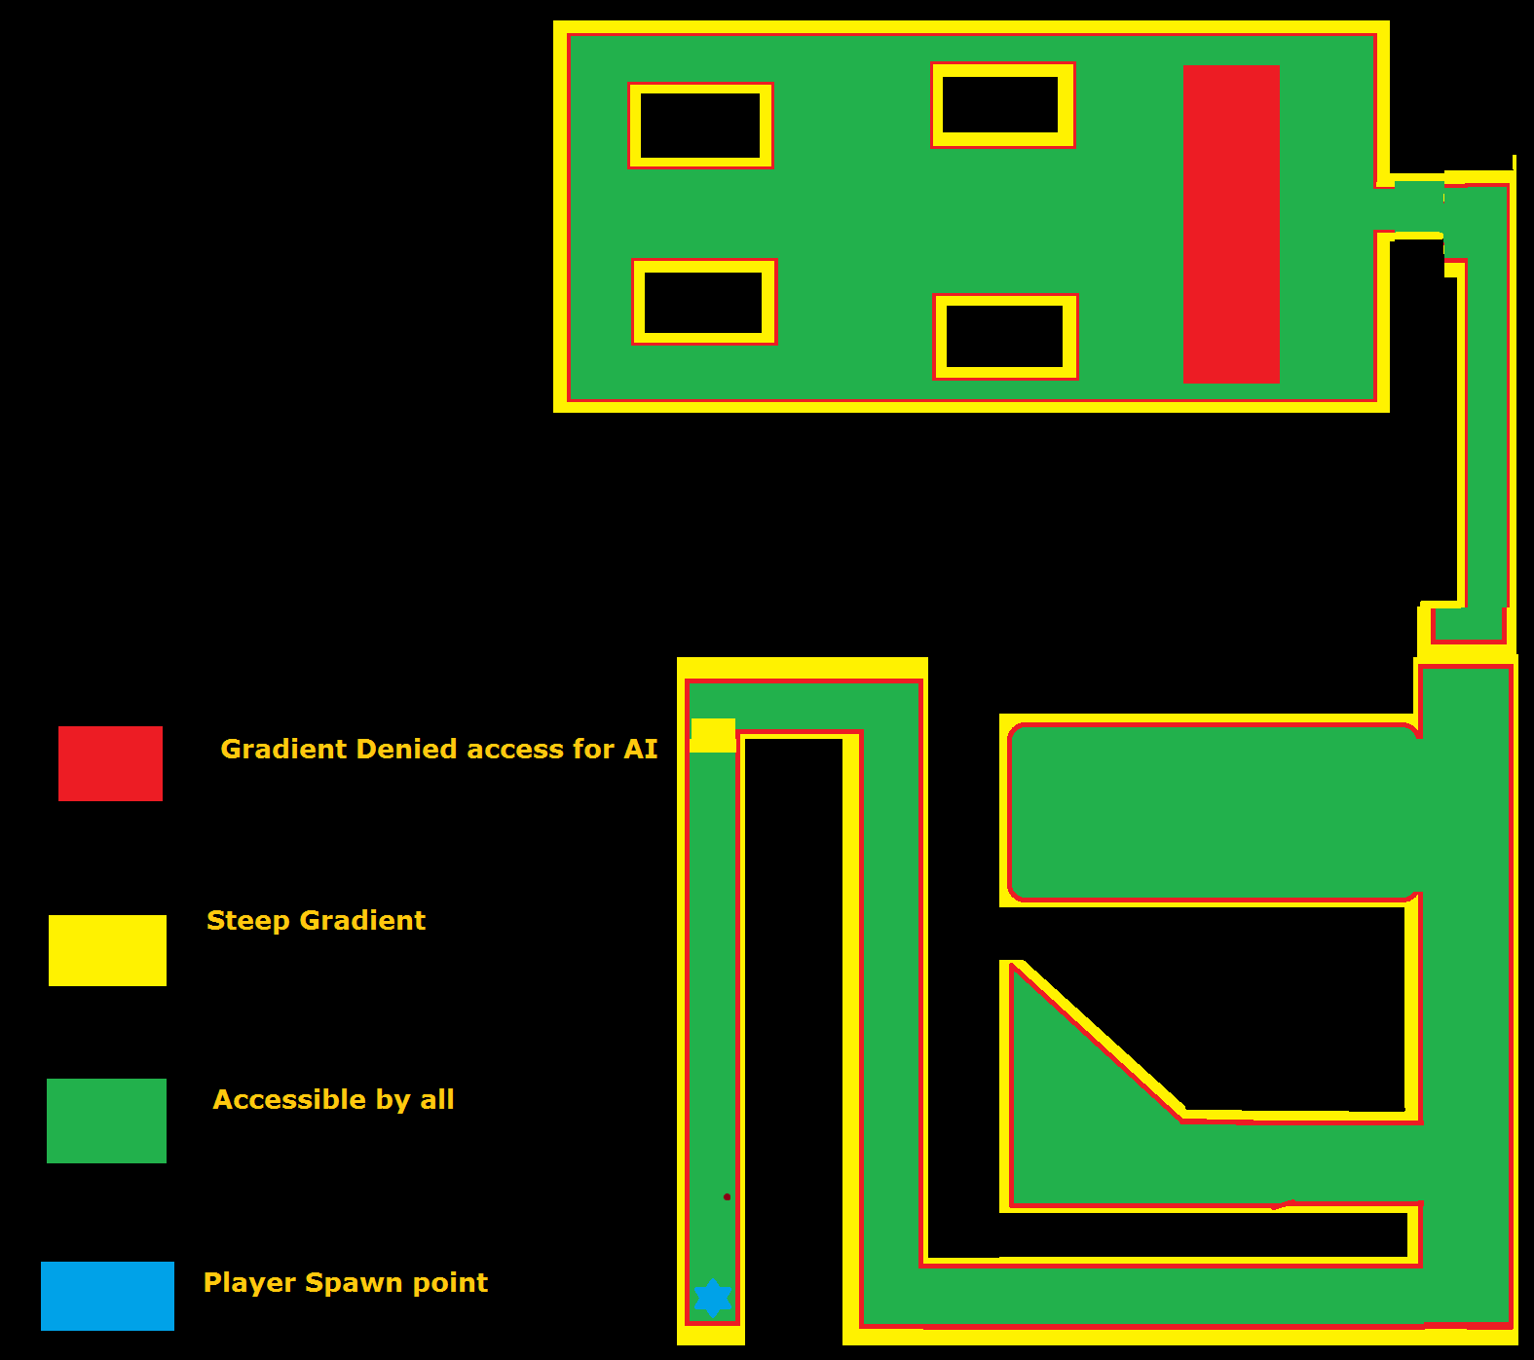

Where black indicates areas that the player cannot get too and are at least 2 times the height of the player model.

## Edit 1

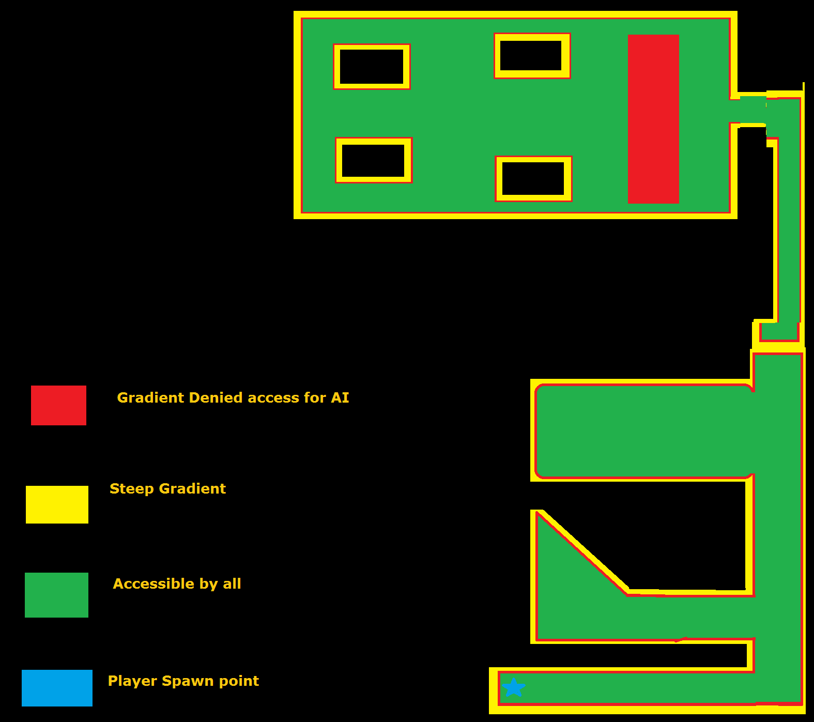Given that development of the game, was not able to match certain time constraints for testing; the design of QTBDIntro has received alterations as follows:

This is to skip the introduction segments of QTBDIntro. So that the Player can get straight to the gameplay.

# Gameplay

## Player Movement System

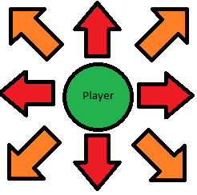The player can move along the X and Y axes, either positively or negatively, to go forwards, backwards, leftwards and rightwards, with W, S, A and D respectively. In addition, they can combine movement along both axes, simultaneously, to more in another 4 directions; forwards and leftwards, forwards and rightwards, backwards and leftwards, as well as backwards and rightwards.

This is represented by the following diagram, where the player is at the centre of these arrows, with the 8 possible directions they can move in (with keys alone, shown to the left):

They can change their movement speed in all directions with the left and right Alt. keys; left Alt. to increase the % of base movement speed and right Alt. to decrease that % of base speed. Currently +/- 0.01 (1%) of their base speed (1.00, 100%). The animation for moving in any of the 8 directions changes as per their movement speed, from running at full pace, to walking, to shuffling.

They can also sprint at 1.75 times their current speed, regardless of what % of base speed they have adjusted it to. If Ctrl is held down before pressing left or right Alt.; it will alter the player’s speed by 10% (positively or negatively), not just by 1%.

## NPC AI Behaviour

This is noted in Appendix A: NPC AI Behaviour.

## Weapons in QTBDIntro

These are noted in Appendix C: Weapons.

## Armour in QTBDIntro

This is noted in Appendix D: Armour.

## Weapon Pick up Confirmation

When a weapon is picked up by the player, a message informing them which weapon was picked up is shown to them for five seconds (Appendix E: Figures: Fig. 1).

## Weapon Statistics System

There is a class, which all weapons have as a member, which stores the various statistics for that weapon, such as its damage, how much ammo it has, uses per active loading mechanism, Etc. This is used instead of spawning objects, say, above the player’s head, for getting the statistics of a given weapon. Using the BrickWeapon as an example; while the BrickWeapon’s Weapon Statistics Actor is spawned in a hidden location, indeed, the actual BrickWeapon Actor, is within the bounds of the level, for the Player to pick up.

## The Tutorial NPC and the Combat Tutorial/Dialog Tutorial

This enemy also uses a copy of the same skeletal mesh and animation blueprint, as the player character and PIBot.

The combat tutorial/dialog tutorial will occur, after PIBot is trying to give the player advice, in either one of two possible routes, then Sacramento will appear and give their introduction.

The player will be put into Cinematic mode at this point in the level, so that Sacramento can give their intro, PIBot will say some dialog towards the player after Sacramento gives their first section of introduction dialog, then will teleport hide out of sight.

Sacramento will be spawned in a section of the canyon, outside the player’s line of sight, but then, will teleport near the player and give their introduction, putting the player in cinematic mode.

In either case, the player can then make various choices, which can affect the combat tutorial in some manor (even causing Sacramento to join their side, so there will not be one), depending on the choices the player makes, Sacramento will either attack the player or side with the player. The player can also begin combat early if they so wish, Sacramento will be frustrated at such though. Sacramento’s introduction can also be interrupted as well, which will cause them to become hostile, only saying part of their second introduction dialog section lines before attacking the player if they get interrupted.

Sacramento has a Prototype Shotgun for their primary weapon, they also have a grenade hidden near where they spawn, before teleporting, which if the player finds, can be used against Sacramento.

If the player has BrickWeapon, it will deal bonus damage against Sacramento, if the player finds and uses Sacramento’s hidden grenade and misses Sacramento, Sacramento will throw an insult their way, if the player hits Sacramento, if Sacramento is hit by the full force of the explosion (for maximum damage, thus, if the grenade explodes within 1,1,1 or so, of Sacramento), Sacramento will teleport away (possibly fighting the player again later on in the level?) and the tutorial will be over.

The Grenade has an explosion particle effect sequence and a sound, for when it explodes, it will kill whichever character is in the blast radius of the time of the grenade exploding, the grenade will be primed to explode upon being thrown, then will explode after approximately 5 seconds have elapsed in game.

## Sacramento’s Movement Animations

Sacramento has the same animations for moving, jumping and dying as the player, but has additional animations for drawing his shotgun from his back, firing that shotgun, reloading it, as well as moving without firing it and moving while firing or reloading, as can be seen in this video presentation:

..\..\Videos\Games Dev. Videos\Quest; To Be Defined; Sacramento Animation Sample.mp4

### Second Section of the Introduction Level

After having their encounter with Sacramento, the player can now freely move into the second section of the canyon

In this section, there will be a six of instances of the first NPC that will always have hostile intent towards the player; Private Matterson (Pvt. Matterson).

### Private Matterson

When the player gets near to where the squad of multiple instances of Private Matterson is, the player will not be attacked by them straight away and can hear them having a light chat while the player and/or Sacramento do not reveal themselves.

Private Matterson has a cheap rifle (represented by the assault rifle from the prototype weapons pack), poor body armour and 100 hit points. Whenever any instance of Pvt. Matterson has the player in their line of sight, as well as them being close enough to that particular instance, they will look at the player, as well as notifying the other instances that they have seen a target and they should look in that direction as well.

Upon turning to face their target, they will draw their weapon and either start shooting, or heading to the location they were most recently looking at, then checking to see if they have line of sight once again, they will keep repeating this cycle until they can see their target, or their target has been eliminated. They will also inform other instances that are nearby, that they have spotted a target nearby, which will cause the other instances to look in that area, also, if they have a target but line of sight is blocked by another instance of Pvt. Matterson, they will move to the left or right, to regain a line of sight to their current target.

# Art

Art for Quest: To Be Defined; is noted in Appendix D: Art Style Guide.

# Sound and Music

There is peaceful, fighting, peaceful_end and fighting_end pieces of background music. There are also dialog recordings for each character, as well as sound effects for most of the weapons. This is detailed further in Appendix E: Sound and Music.

# User Interface and Game Controls

## Main menu

The main menu is a UMG (Unreal Material Graphic) Widget, the mouse cursor is shown to the player, so that they can use this GUI (Graphical User Interface), which shows five buttons upon being created and added to the viewport, these are:

* New Game
* Load Game
* Options
* Credits
* Exit

### New Game

At the moment, this contains one button, the start button, this will start the game by opening the first level.

#### Start

Pressing on this button will stream load, open the first level and spawn the player at the first level’s starting spawn point, this level is called QTBDIntro, mostly a linear canyon, which the player must follow.

#### Credits

Pressing this button, will display the credits for the game.

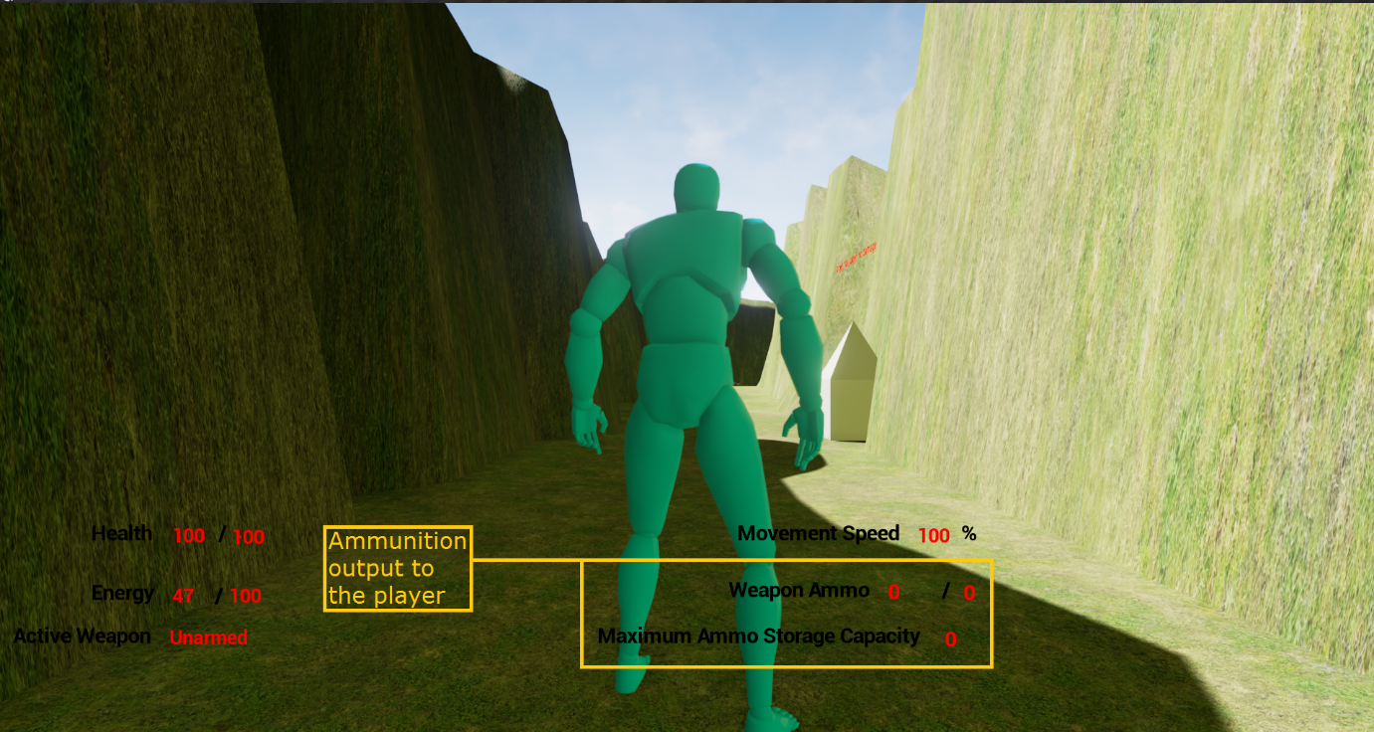This is Main Menu UMG Widget Version 1.0.0 (the first version).

## DefaultPlayerHUD 1.0.0

This is from an earlier version of the game (from late 2014/early 2015).

### Weapon Ammo HUD Element

The screenshot on the previous page; shows this element of the player’s HUD, highlighted in a yellow box, with a caption to the left.

This text; Shows the current loaded ammo count for the weapon, out of the ammo currently stored for this weapon. The maximum ammo count is also shown, for the maximum quantity of ammo that the Player can carry for this weapon (weapons that are picked up, that use ammo, will always have an initial quantity of ammo). This is if the weapon uses ammo, if not; the values for the Player’s weapon, that are shown to the Player, are that of 0 (e.g. for melee weapons).

# Test Report

For testing; the initial sequences in QTBDIntro were removed (with this level receiving a renaming to QTBDIntroTesting), modifying the starting point of the level, to the point in the canyon which was a corner (now a dead end), which after the Player would have followed around to the left; would soon encounter Sacramento. This is true for the first test that was completed, but for all subsequence tests (from this set of 5); the Player’s encounter with Sacramento is removed, so that control is not taken away from the Player, when quite soon after Sacramento appears before the Player, 6 instances of Private (Pvt.) Matterson navigate to the Player’s within combat range of the Player (even though they should not), so the Player would want full control of their movement and interaction when this occurs.

## First Testing Version of Q: TBD

In the first version, issues that the tester identified/indicated to me via their feedback, included that of:

* Pick-up game entities are not clear to identify
* Not having mouse visibility for the (single) dialog section, close to the Player’s spawn point
* Controls are never mentioned
* By not having knowledge of the control required to complete the first dialog section, one is unable to complete the level’s objective

A series of ‘hotfixes’ to such issues, that were utilised for the version of Q: TBD used in the next series of tests; is that of informing the Player of the controls, by using a widget to show them before the level starts and removing the encounter with Sacramento (in relation to the mouse visibility issues).

## Second Testing of Q: TBD

In the second version, issues that the testers identified/indicated to me via their feedback, included that of:

* Sporadic bullet behaviour (that of not following the respective velocity, given their initial propulsion force
* Inability to find the end of the canyon (for the objective; this is as there is no exit/end to the canyon at present)
* No waypoint indictor for the current objective
* The camera would get pushed towards the Player (limiting their field of view), if a character approached the Player from behind, ultimately getting within approximately 50 Unreal Units (UU; 1cm = 1UU) of them
* Inability to damage enemies with any weapon (projectile based, or other tools to inflict damage, such as one’s fists)
* Terrain is unsmooth at steep gradients within the canyon
* No options when setting up the game, to adjust the difficulty
* It is possible to escape from the piece of terrain that is the map, into the void of the game world
* The Player can only throw the Brick Weapon once and the Brick Weapon deals no damage to Pvt. Matterson
* PIBot and CombatAdmin’s assistance towards the Player, is unclear
* AI issues (such as Pvt. Matterson not having particular effectiveness against the Player)
* Information is obfuscated from the Player (such as the damage of their weapon, the armour’s effectiveness, as well as durability, etc.), when such information should have clarity from the Player’s point of view , to inform them about the effectiveness of their items

A series of ‘hotfixes’ to resolve (at least some of) these problems; will receive implementation into the game, with the intent to complete such before the deadline (on the 14th of December, this paragraph was composed on the 9th of December).

# Post-mortem

# Appendix A: NPC AI Behaviour

## How PIBot behaves in the first level

As described in the ‘Character’ section, PIBot will start off in the first level, on the ground, deactivated. When the player gets close enough (as determined by PIBot’s Proximity Detection Sphere), PIBot will play the death animation that made PIBot appear deactivated, in reverse, so PIBot will appear to jump up, then after an intro sequence, will follow the player around, attempting to maintain a proximity of 50 Unreal Units to the player.

PIBot uses a Nav. Mesh to follow the player around, this Nav. Mesh is as big as the whole level, allowing PIBot to find the player, even if PIBot does not have line of sight to the player.

PIBot uses a duplicate of the player’s Skeletal Mesh, with a grey metal coloured material painted onto it, as well as using all of the player’s animations, with a copy of their Animation Blueprint, as their Skeletal Mesh is a duplicate of the one the player uses.

The player can just leave PIBot to jump up and begin their intro, without being held back, but PIBot will cut themselves short when the player gets to a certain point, in the path ahead, then shout; “Hey, wait up!” (or another similar phrase), and run after them (at an increased speed, so that they can catch up to the player?). The player is stopped after causing the trigger to fire, but PIBot does not move to them, they are also stopped if they enter the volume again, fix this, so PIBot does shout something at them, they are stopped only once and are also told to enter their name, before moving on.

## The CombatAdmin

When the player enters the second crevice of the canyon, at a certain point, the CombatAdmin will fly in and give its introduction, similar to PIBot, the player can keep going, then the CombatAdmin will complain about being interrupted by the player, PIBot will also respond to the Com Ad complaining.

The CombatAdmin will not use a Skeletal Mesh (for now), just a few primitive shapes, for a construction; with a similar build to that of certain current age drones (such as a Predator Drone), even though the CombatAdmin is not a drone though, but it is a robot, like PIBot, so is completely automatous.

## Sacramento’s AI

The logic of Sacramento’s behaviour tree is detailed below:

# Appendix B: Class Inheritance Structure

This is as per the diagram below:

# Appendix C: Weapons

All weapons in QTBDIntro are mentioned here (with their respective Weapon Statistic Values):

|  |  |  |  |  |  |  |  |
| --- | --- | --- | --- | --- | --- | --- | --- |
| Name | Damage Per Attack | Rate of Attack | Requires Ammo? | Reload Duration |  |  |  |
|  |  |  |  |  |  |  |  |
|  |  |  |  |  |  |  |  |
|  |  |  |  |  |  |  |  |

## The Brick Weapon

The first weapon the player can get, is a brick, which they can throw at enemies and pick it up again if they so wish.

The brick will cause ~10 points of damage to enemies, twice that of unarmed combat. The brick is a ranged projectile weapon, so they would not have to get as close to enemies, in order to damage them. A radial impulse (force) component provides the respective force to the brick, when it is thrown.

The BrickWeapon is a sub-class of QTBDWeapon, which in of itself, is a sub-class of QTBDItem.

# Appendix D: Art Style Guide

The art style ultimately decided upon for the game; is that of a ‘realistic’ (with varying degrees of authenticity, in relation to such).

Sketches aiding in coming to this decision, are as follows:

## Sketches

### Player Character

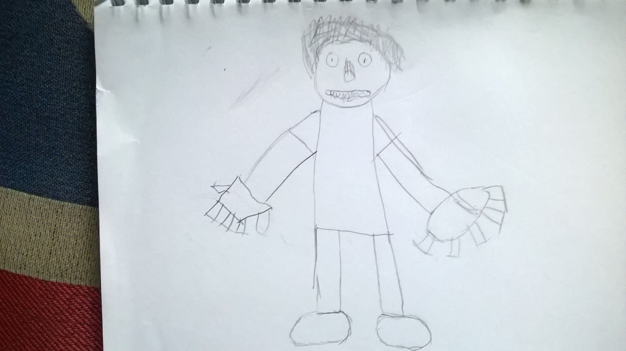

### PIBot (Based on Fig. 2, from Appendix E: Figures)

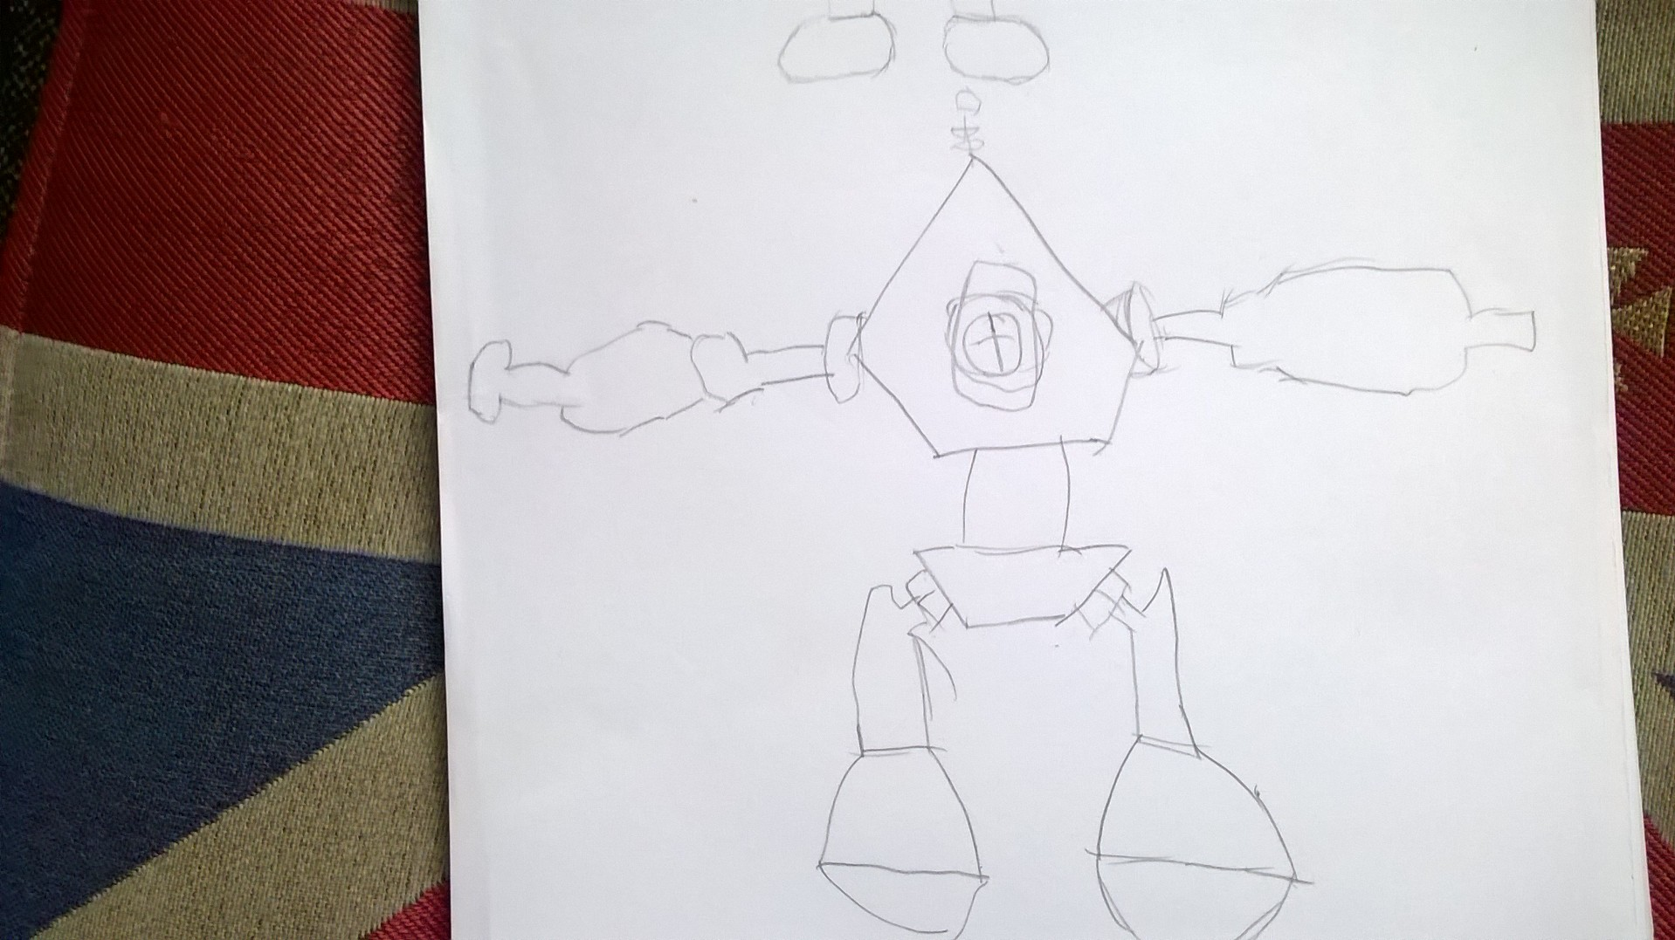

## Asset Prototype Screenshots

### Main Menu

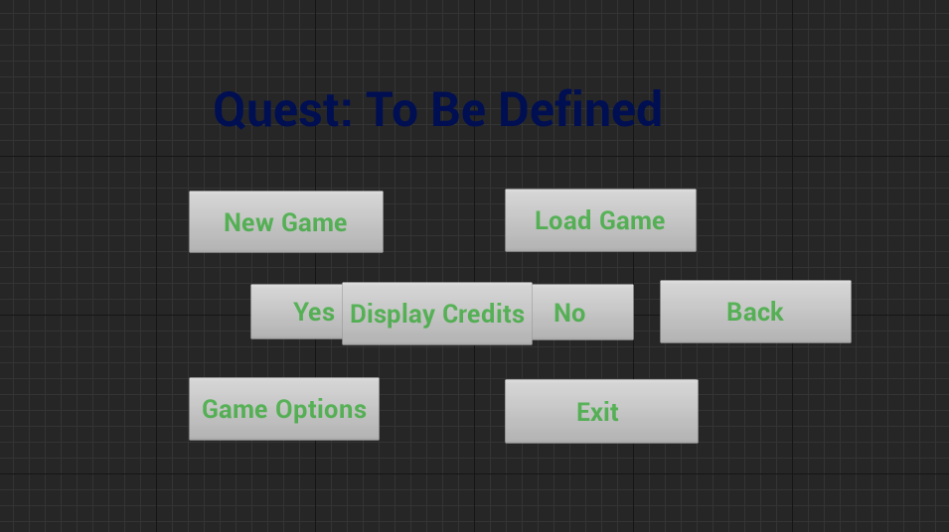

### Default Player HUD

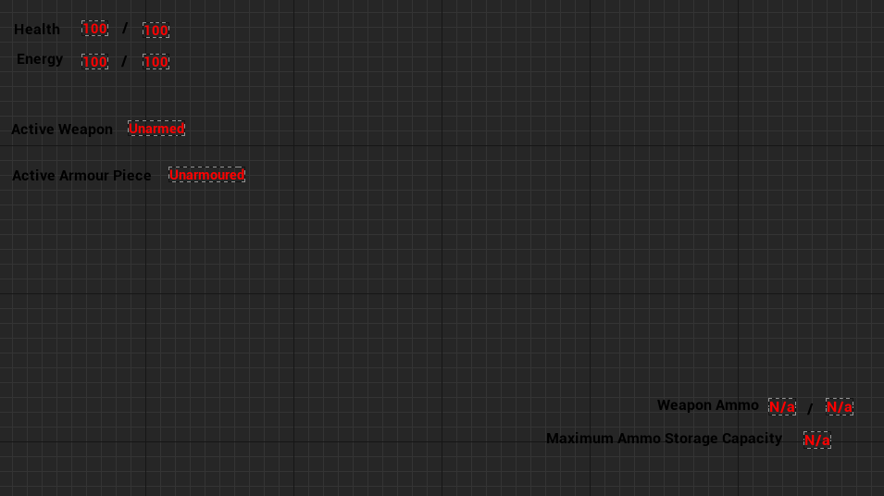

## 3DSMax Prototype Render Views

### Pvt. Matterson 3DSMax Render View

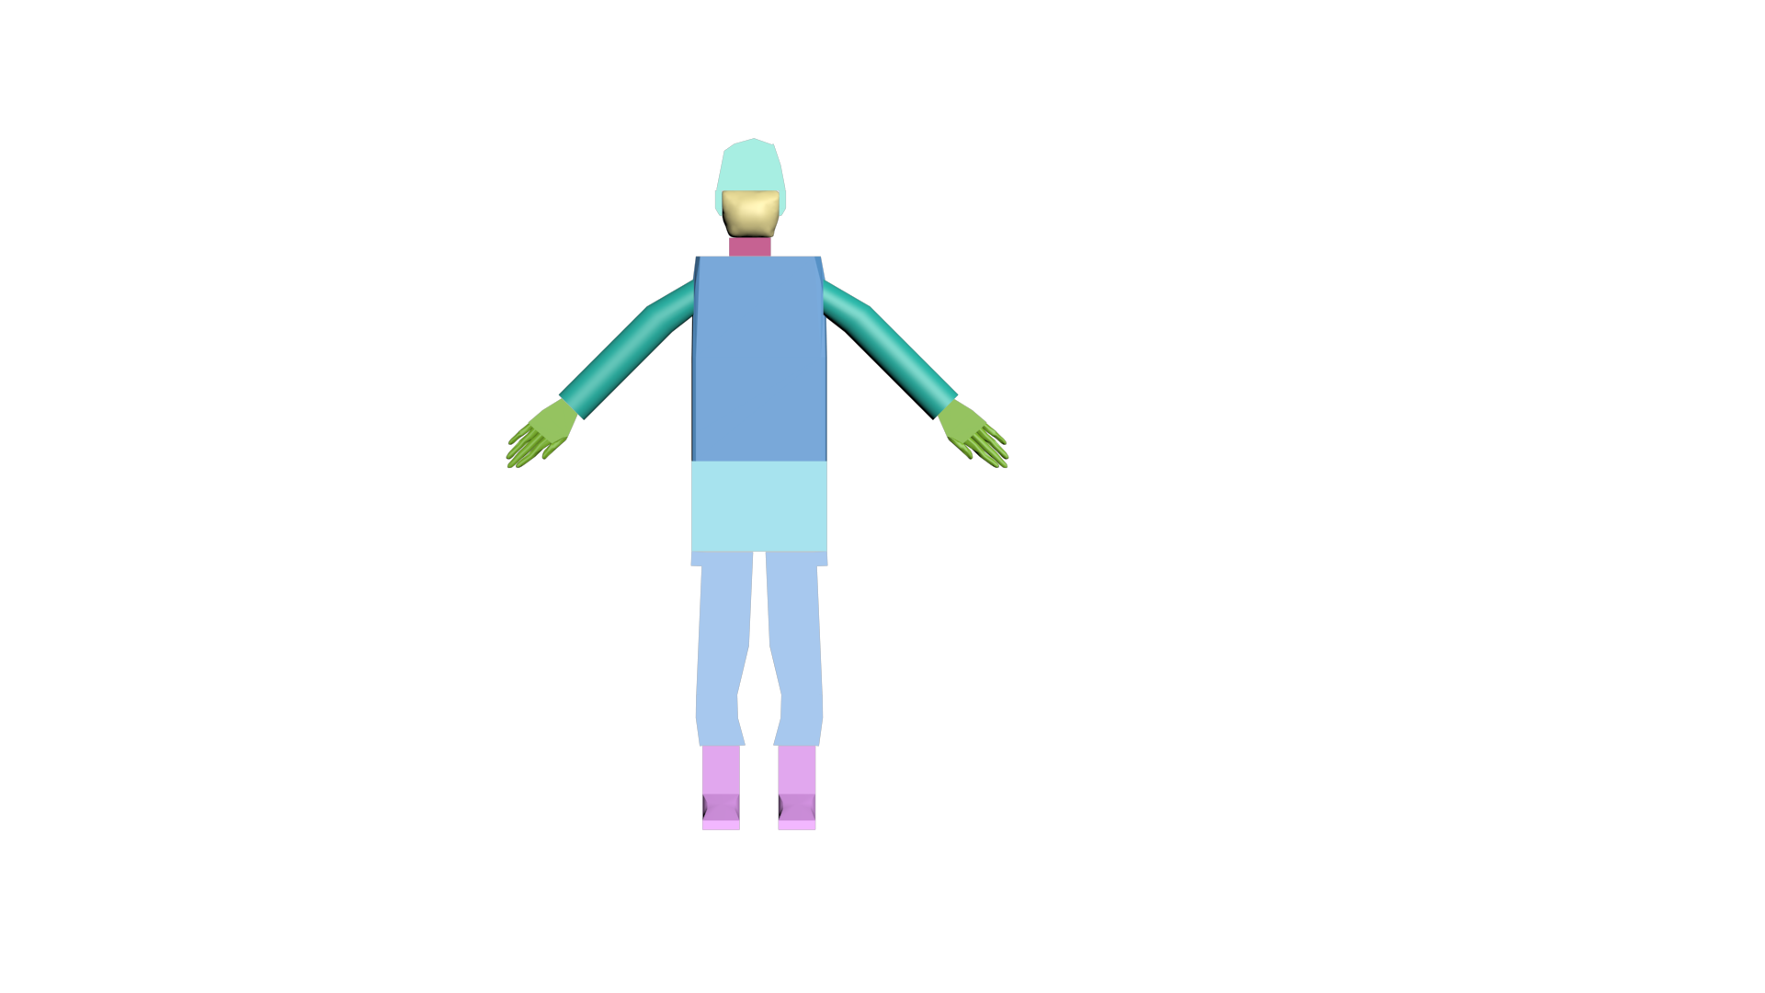

## Top-Down Level Overview

### QTBDIntro

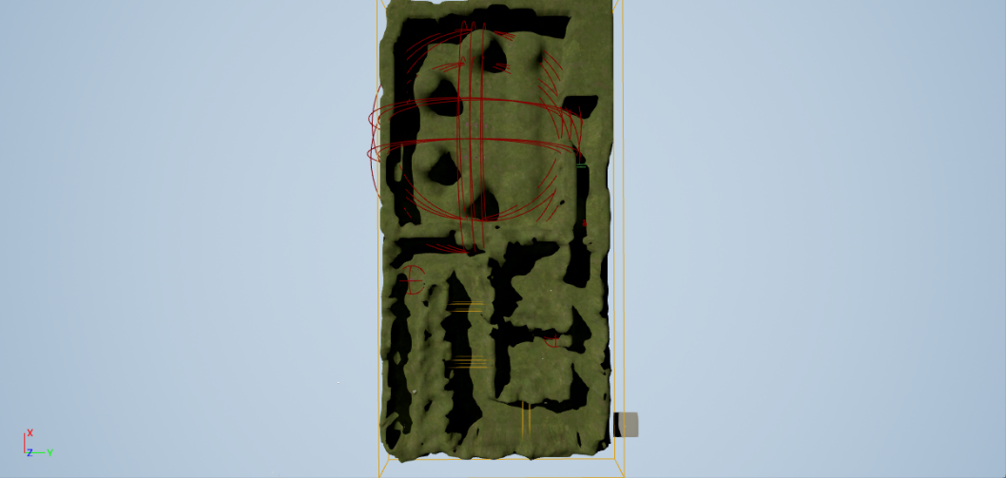

This is a top-down view of the initial design/implementation of QTBDIntro. With the Player starting the level towards the bottom-left corner of this terrain piece.

### QTBDIntroTesting

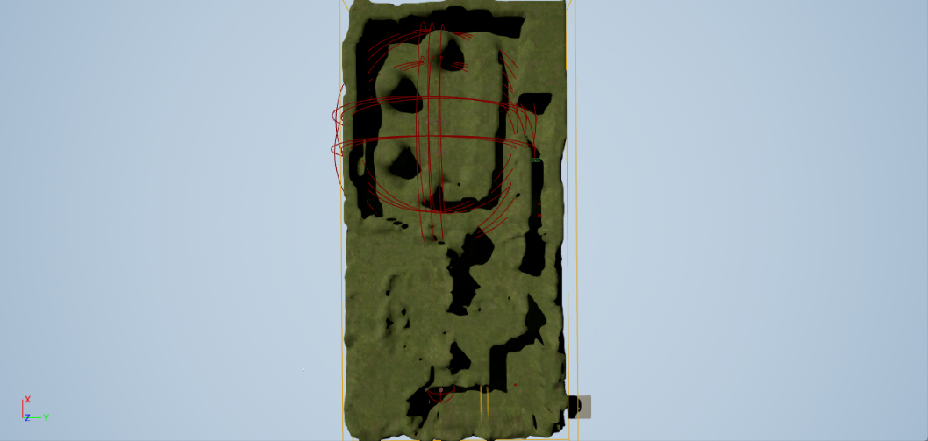

This is a top-down view of the testing version of QTBDIntro (dubbed QTBDIntroTesting). Where the entire bottom-left segment of the canyon, was cut out, with the Player’s spawn point getting moved to the bottom-middle segment of the canyon. This is due to the initial segment of this level, not showing off the gameplay mechanics of Quest: To Be Defined, until after several dialog sequences. The yellow box towards the bottom-right portion of the level (indicating when Sacramento will appear to the Player); was also cut, due to the constraints placed on the Player, as mentioned in the Testing section of this document.

# Appendix E: Sound and Music

A list of all the music and sound put into Quest: To Be Defined (used or not):

Music

* Peaceful Background; Peaceful and Peaceful_end (stinger).
* Combat Background; Fighting and Fight_end (stinger).

## Dialog

Most of the dialog messages are recordings of the voices from some of my friends, 1 character’s dialog is recorded by me though:

* PIBot – Mads Larsen
* CombatAdmin – James Moran
* Sacramento - [Eddie Gustavsson](https://www.facebook.com/eddie.gustavsson.33)

### PIBot

* “Greetings unknown person! I think I must have been falling asleep here, waiting for someone like you to walk down the road and notice me. I am PIBot, that is; Personal Intelligence Robot, I say falling asleep, but I don’t mean really, I am a robot after all, but I can imitate sleep, I must have done so, while I was being bored, waiting. Guess I must have been left here after the war of 21’, ah well. As such, I have something of the upmost importance to tell you, but first; what is your name? Please tell me.”
* “Right…so you won’t give me your name then? I’ll just have to know you as ‘Unknown’, then, hmm, the unknown person; not too interesting…”
* “Ah! So that is your name eh? That is very interesting! What a kind person you must be. I will record this name of yours, in my primary storage banks.”
* “Ok then, I’ll follow you! Let’s go down the road a bit, as I have something to tell you, don’t want anyone sneaking up on us you see so down the road a bit, then I’ll tell you.”
* “Hey! Wait up there! W-w-what is your name? I do have something important to tell you, wait up!”
* “Ok, that’s far enough, what I need to tell you is of the upmost importance, it is tha-”
* “Good to know, other robot that appeared out of nowhere.”
* “Regardless, I must tell you what I know, or we could be in trouble, what I need to tell you, is tha-"
* “Please stop wondering off, I don’t think you know where you are going, I can help you with what I kno-”
* “Wait! Don’t go wandering off friend!”
* “Come back friend! Wait, who are you?”
* “I will move over here for the time being, I do not want to aggravate this person whom appeared out of nowhere”
* *Teleports back near the player* “I will stop hiding for the moment then, I am still trying to recall my intended destination, to show this person something important”
* “I know that it is important, but this piece of information, is hard locked into my storage banks, so I am not sure what this important entity is…”

### CombatAdmin

* “Greetings team that requires my help and assistance! I am the CombatAdmin. I administrate combat, as well as a few other tasks, in addition to combat administrating.”
* “Where are you going, unknown entity? Do not run off!”
* “I will execute Combat administration immediately, beginning now.”

### Sacramento

* “Ah, there you are, I am the one, the only, Sacramento! Awhaw, tell me, where are you off to then?”
* “Good…then you won’t mind staying here now, will you?”
* “Ah, one of those old PIBot type robots hmm? Tell me then robot, where are you and your friend heading to?”
* “Ahh…what is so very important there then?”
* “Oh, I know where you can go….”
* “Ah...I have a plan to inform you of then, you see, I have scouted out what is up ahead, I have seen a bunch of military grunts there, I will assist you with them, by using this ground to ground missile I have here: *Shows the missile launcher to the player* I just require a target location of your choosing, I also have a shotgun on me, to blast them with. Let’s get started then.”
* “How dare you! I was going to inform you of my plan! Sacre bleu! *Draws shotgun*”
* “Dodge this fiend!”
* “I have you now!”
* “Stop trying to flee!”
* “You won’t get away!”
* “Time for a reload…”
* “Wait a moment, then I have you…”
* “I will catch you!”
* “You won’t escape me!”
* “You did not stand a chance…”
* “Why wouldn’t you listen…”
* “You’re in trouble now-ARGHRH!!”
* “I did not deserve this-ARGHRH!!”

## Other Sound

### Shotgun

* 5 sound for firing
* 15-20 sound for reloading (3/4 different types of sound at different points in reloading)
* 5 sounds for impact

### Pistol

* 5 sounds for impact
* Sounds for firing and reloading are present, but not implemented in the game (5 for firing, 15-20 sounds for reloading)

### Rifle

* 5 sound for firing (but not often played due to errors as to when these sounds should receive output to the Player)
* 15-20 sound for reloading (3/4 different types of sound at different points in reloading)
* 5 sounds for impact

These are sounds for the prototype weapons, of the weapons from this pack of 7 weapons, that are used in Quest: To Be Defined, © Adia Entertainment 2016.

# Appendix F: Figures

## Figure 1: Weapon/Item Pickup Confirmation

## Figure 2: Galactic Ranger from Ratchet and Clank: Up Your Arsenal

<http://www.deviantart.com/art/Ratchet-and-Clank-UYA-Galactic-Ranger-510492872>

